Summer Reading
Incoming Grade 3
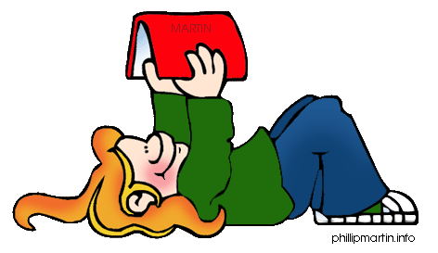
Incoming Grade 3:
If you earned a 1 or a 2 on your report card in Reading, please choose one of the books below: (Note to parents: Reading difficulty increases from top to bottom.)
Stage Fright on a Summer Night by Mary Pope Osborne
Interrupting Chicken by David Ezra Stein
One in the Middle is the Green Kangaroo by Judy Blume
Cam Jansen: The First Day of School Mystery by David A. Adler
Horrible Harry Goes to the Moon by Suzy Kline
Goosebumps: How I Learned to Fly by R. L. Stine
Freckle Juice by Judy Blume
Whatever After: Fairest of All by Sarah Mlynowski
Whatever After: If the Shoe Fits by Sarah Mlynowski
Aliens for Breakfast by Stephanie Spinner
If you earned a 3 or a 4 on your report card in Reading, please choose one of the books below: (Note to parents: Reading difficulty increases from top to bottom.)
Whatever After: Sink or Swim by Sarah Mylnowski
The Secret Garden by Frances Hodgson Burnett
Who Stole the Wizard of Oz? by Avi
Hurry Up Houdini by Mary Pope Osborne
Kickers: The Ball Hogs by Rich Wallace
Punished by David Lubar
The Trouble with Chickens by Doreen Cronin
Here’s Hank: Bookmarks are People Too! by Henry Winkler and Lin Oliver
Dandelions by Eve Bunting
A Song for Harlem by Pat McKissack

Summer Reading
Incoming Grade 4
Incoming Grade 4: If you earned a 1 or a 2 on your report card in Reading, please choose one of the books below: (Note to parents: Reading difficulty increases from top to bottom.)

The Secret Garden by Frances Hodgson Burnett
The Trouble with Chickens by Doreen Cronin
Here’s Hank: Bookmarks are People Too! by Henry Winkler and Lin Oliver
Dandelions by Eve Bunting
A Song for Harlem by Pat McKissack
Ancient Greece and the Olympics by Mary Pope Osborne
Monday with a Mad Genius by Mary Pope Osborne
Sheep by Valerie Hobbs
From the Mixed-Up Files of Mrs. Basil E. Frankweiler by E.L. Konigsburg
The Great Turkey Walk by Kathleen Karr
If you earned a 3 or a 4 on your report card in Reading, please choose one of the books below: (Note to parents: Reading difficulty increases from top to bottom.)
Bunnicula: A Rabbit-Tale of Mystery by Deborah and James Howe
Frozen Stiff by Sherry Shahan
In the Year of the Boar and Jackie Robinson by Bette Lord
Muggie Maggie by Beverly Cleary
Running Out of Time by Margaret Peterson Haddix
Esio Trot by Roald Dahl
26 Fairmount Avenue by Tommie dePaola
The Cricket in Times Square by George Selden
The Mysterious Benedict Society by Trenton Lee Stewart
Stuart Little by E.B. White

